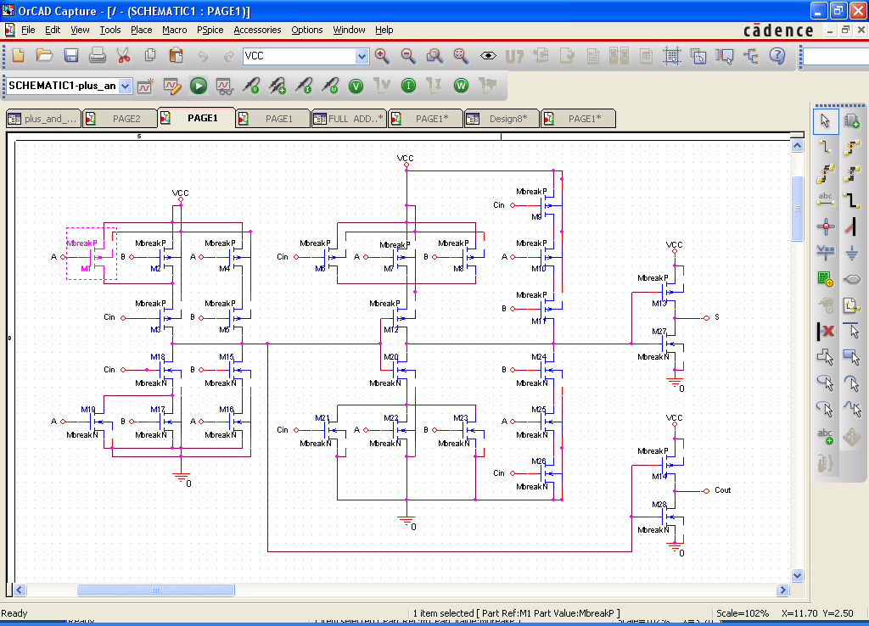

* source FULL ADDER HAMPLE

M_M9 N7297224 CIN VCC VCC MbreakP

M_M20 N7297232 N7297086 N7297418 N7297442 MbreakN

M_M22 N7297418 A 0 0 MbreakN

M_M23 N7297418 B 0 0 MbreakN

M_M13 S N7297232 VCC VCC MbreakP

M_M26 N7297240 CIN 0 0 MbreakN

M_M15 N7297086 B N7297082 N7297016 MbreakN

M_M16 N7297082 A 0 0 MbreakN

M_M6 N7297300 CIN VCC VCC MbreakP

M_M18 N7297086 CIN N7297066 0 MbreakN

M_M2 N7297090 B VCC VCC MbreakP

M_M17 N7297066 B 0 0 MbreakN

M_M19 N7297066 A 0 0 MbreakN

M_M24 N7297232 B N7297236 0 MbreakN

M_M7 N7297296 A VCC VCC MbreakP

M_M25 N7297236 A N7297240 0 MbreakN

M_M21 N7297418 CIN 0 0 MbreakN

M_M28 COUT N7297086 0 0 MbreakN

M_M1 N7297090 A VCC VCC MbreakP

M_M27 S N7297232 0 0 MbreakN

M_M12 N7297232 N7297086 N7297296 N7297288 MbreakP

M_M3 N7297086 CIN N7297090 VCC MbreakP

M_M14 COUT N7297086 VCC VCC MbreakP

M_M4 N7297502 A VCC VCC MbreakP

M_M5 N7297086 B N7297502 VCC MbreakP

M_M8 N7297300 B VCC VCC MbreakP

M_M10 N7297228 A N7297224 VCC MbreakP

M_M11 N7297232 B N7297228 VCC MbreakP